**(ONLINE QUIZ SYSTEM USING PHP)**

Submitted in partial fulfillment of the requirements

of the Mini-Project 1/2 for Second Year/Third Year of

Bachelors of Engineering

by

(1.Kabir Selot 2.Mahira Fakih 3.Mariyum Siddique 4.Humza Khan)

(Roll No. 37 , 10 , 51 19)

Guide:

(Shaikh Mohd Ashfaque)



Department of Computer Engineering

Rizvi College of Engineering



University of Mumbai

20__-20__

**CERTIFICATE**

This is to certify that the mini-project entitled **“Online Quiz System using Php”** is a bonafide work of **Kabir Selot (37), Mariyum Siddique (51), Hamza Khan (19), and Mahira Khan (10)** submitted to the University of Mumbai in partial fulfillment of the requirement for the Mini-Project 1/2 for Second of the Bachelor of Engineeringin **“Computer Engineering”**.

(Name and sign)

**Guide**

_______________ ______________

Prof. Shiburaj Pappu Dr. Varsha Shah

**Head of Department** **Principal**

Declaration

I declare that this written submission represents my ideas in my own words and where others' ideas or words have been included, I have adequately cited and referenced the original sources. I also declare that I have adhered to all principles of academic honesty and integrity and have not misrepresented or fabricated or falsified any idea/data/fact/source in my submission. I understand that any violation of the above will be cause for disciplinary action by the Institute and can also evoke penal action from the sources which have thus not been properly cited or from whom proper permission has not been taken when needed.

-----------------------------------------

(Signature)

-----------------------------------------

(Name of student and Roll No.)

Date:

**ABSTRACT**

This document specially mentions the details of the project how it was developed, the primary requirement, as well as various features and functionalities of the project and the procedures followed in achieving these objectives.

ONLINE QUIZ forms the lifeline of the Educational Institutes to the functioning of the Examination. It is very essential for an Institute to handle the Examinations and their results. It is very useful for an Institute to test its students continuously for their mutual development. This system is helpful for conducting (M.C) Multiple Choice Examinations which can be conducted regularly as well as for surprise tests and provides immediate results saving the precious time of faculties to check the papers and prepare mark sheets.

The IT initiatives have encouraged various Organizations to develop systems to facilitate their day to day operations. The ONLINE QUIZ will include various Courses (IT, Commerce, Science, etc) and subjects for conducting examinations. This system helps in conducting examinations quickly and can thus help in saving time and the operations will be carried out efficiently.

With the effective use, any Institute can apply the "ONLINE QUIZ" for conducting

quick examinations and getting better results in less time.

Index

|  |  |  |  |  |
| --- | --- | --- | --- | --- |
| Sr. No | Title | | | Page No |
| 1. | Introduction | | |  |
| 2. | Review and Literature | | |  |
|  | 2.1. | Paper 1 | |  |
|  | 2.2. | Paper 2 | |  |
| 3. | Theory, Methodology | | |  |
|  |  |  | |  |
|  |  |  |  |  |
| 4. | Results and Discussions | | |  |
| 5. | Conclusion | | |  |
| 6. | References | | |  |
|  |  | | |  |
| 7 | Acknowledgement | | |  |
| 8 | Publication | | |  |

**Chapter 1**

**Introduction**

On-line examinations contents providers to focus on creating effective assessment questions and focusing on exam's feedback delivery to students. In the paper we present techniques that are pertinent to the elements of assessment process: answers submission, computerized grading, and feedback after submission

As the modern organizations are automated and computers are working as per the instructions, it becomes essential for the coordination of human beings, commodity and computers in a modem organization.

The administrators instructor, Students who are attending for online examination can communicate with the system through this projects, thus facilitating effective implementation and monitoring of various activities of Online Examinations like conducting Exams as per scheduled basis and delivering result to that particular use or student. And the details of students who attempted Online Examination are maintained at administrator

# Existing System & need of the System :

Existing system is a manual one in which users are maintaining books to store the information like Student Details Instructor Details,Schedule Details and feedback about students who attempted exam as per schedule... It is very difficult to maintain historical data.

Scope of Work : Technological advancements in this era of digitization along with being a boon to the world have been advantageous to the educational sector too. The introduction of online exam software replaced the conventional system of assessment. The various examination conducting agencies are now able to evaluate the test takers freely and cost-effectively through computer-based tests. Today's article discusses the scope and objectives of an online examination system Before proceeding further let us understand the concept of online examination software. Exam software allows users to take online tests and automatically generate results based on the answers marked by the users. Lets now discuss the reasons for the introduction of online examination in the modes of conducting an assessment. Conduct exams effortless: Computer-based tests as a method of conducting an assessment enable users to manage an exam easily. The functionalities of an exam software such as user-friendly dashboard, multiple languages, support for multiple question types and formats, detailed reporting, automatic instant results help in smooth conduction. Reduce exam anxiety Amongst test takers:The flexibility associated with computer-based tests reduces exam anxiety among test takers as they can take the exam at any time of the day that coincides with their preferred sleep/wake cycle.

Promote social interaction between the test taker and experts:

An online environment promotes exam preparation with experts or peers as they can review the course content together. Online assessment possible through exam software lays the real foundation of academic teaching as facilitates discussion with teachers or other students.

## Prevents cheating:

Cheating among the test-takers in the examination hall is one of the major drawbacks of pen paper-based assessment. Online examination managed avoids the possibilities of secretly using unfair means to get the right answers. The presence of various functionalities in exam software prevents cheating irrespective of the test taker's location.

## Safe and secure data:

Various tools offered by exam software have enabled the assessment conducting agencies to manage the crucial data related to examination questions and test-takers safely. Reduce administrative burden: Organizing and tensing exams online not only reduces an organization's administrative burden but also saves cost and time. Online examination with its objective to make evaluation massive but simple, cost-effective and faster has replaced the pen paper-based assessment. The examination managing agencies have started preferring computer. based test to instill their lost faith in the method of conducting an evaluation. Thus online examination software offered by Softness is one of the most advanced software for conducting tests.

**Chapter 2**

**Review of Literature**

Online examination system is a web-based examination system where examinations are given online. Either through the internet or intranet using computer system. The main goal of this online examination system is to effectively evaluate the student thoroughly through a totally automated system that not only reduce the required time but also obtain fast and accurate results. The main objective of our software is to efficiently evaluate the candidate thoroughly through a fully automated system there is no need of paper and pen. The user can write exam without going to the exam centre. Also the website will provide a good. The very first step of any research process is to choose a topic. With a literature review, the parameters will be set by a central research question. Always keep in mind the purpose of a literature review is to represent previously conducted research and its developments related to a specific research question. Online Quiz System Project is really an interesting platform for testing your knowledge. It will provide users an online interface where they solve different quizzes online. The other interface will be controlled by the operator who will responsible to create, design and update the quizzes. The users or students will enter their particular ta login and solve a quiz of their choice. may contain MCQs or other Sormat as designed by the admin or teacher.

➔ interesting online quiz

➔ Store and process quiz data

➔ Assist teachers in quiz creation

➔ All information of new quizzes

➔ Improve job application affairs

➔ Overcome the old procedures

➔ Easy information refreshing

➔ Backup information .

Online Quiz System Project will contain all information related to quiz, the questions involved in quiz, instructions to solve the quiz, passing score details and other necessary details. The user will be shown the result once may have finished their quiz Online Quiz System Project will also help improve many areas such as education and knowledge gathering. It also helps to overcome the drawbacks of the current system.

**Data Flow Diagram :**

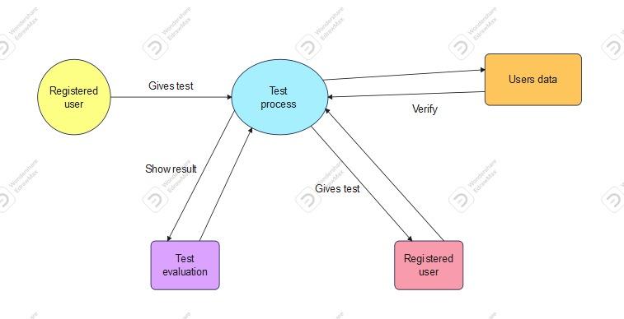

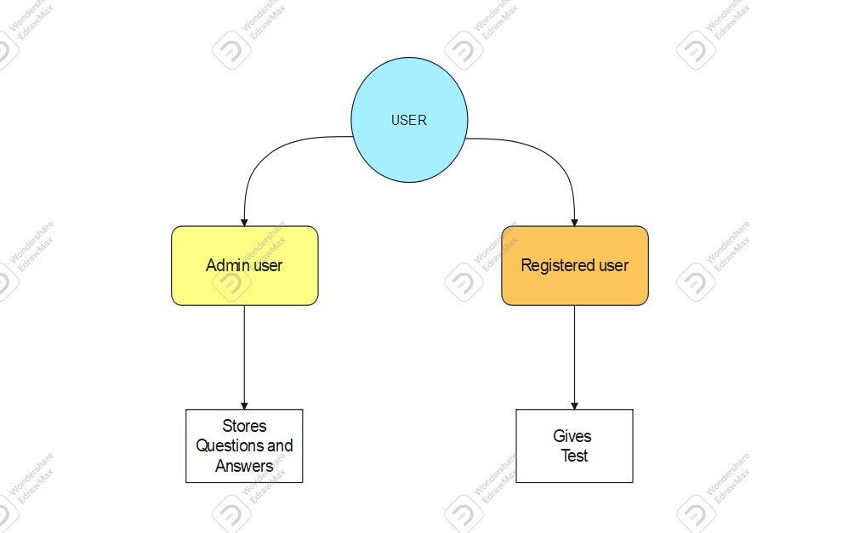

**Chapter 3**

**Report on the Present Investigation**

DEVELOPMENT TOOLS : ➢

1, Module : VS code , MySQL ,Xampp .

2.Used Apache host server.

3.Web Browser : Chrome . ➢

4.Language : Php.

SYSTEM REQUIREMENT :

ON CLIENT SIDE :

1. Operating System (ANY) ➢
2. Web Browser(ANY)

ONE SERVER SIDE

1. Web server(APACHE) ➢
2. Php➢
3. MySQL

Php:

Php Hypertext Preprocessor (or simply PHP) is a server-side scripting language designed for Web development, but also used as a general-purpose programming language. It was originally created by Rasmus Lerdorf in 1994,] the PHP reference implementation is now produced by The PHP Group. PHP originally stood for Personal Home Page, ] but it now stands for the recursive acronym PHP: Hypertext Preprocessor. PHP code may be embedded into HTML code, or it can be used in combination with various web template systems, web content management systems, and web frameworks. PHP code is usually processed by a PHP interpreter implemented as a module in the web server or as a Common Gateway Interface (CGI) executable. The web server combines the results of the interpreted and executed PHP code, which may be any type of data, including images, with the generated web page. PHP code may also be executed with a command-line interface (CLI) and can be used to implement standalone graphical applications.

Xampp

XAMPP is a free and open source cross-platform web server solution stack package developed by Apache Friends, consisting mainly of the Apache HTTP Server, MariaDB database, and interpreters for scripts written in the PHP and Perl programming languages. XAMPP stands for Cross-Platform (X), Apache (A), MariaDB (M), PHP (P) and Perl (P). It is a simple, lightweight Apache distribution that makes it extremely easy for developers to create a local web server for testing and deployment purposes. Everything needed to set up a web server – server application (Apache), database (MariaDB), and scripting language (PHP) – is included in an extractable file. XAMPP is also cross-platform, which means it works equally well on 5 Linux, Mac and Windows. Since most actual web server deployments use the same components as XAMPP, it makes transitioning from a local test server to a live server extremely easy as well

Mysql

MySQL Workbench is a unified visual tool for database architects, developers, and DBAs. MySQL Workbench provides data modeling, SQL development, and comprehensive administration tools for server configuration, user administration, backup, and much more. MySQL Workbench is available on Windows, Linux and Mac OS X

HTML

Hypertext Markup Language (HTML) is the standard markup language for creating web pages and web applications. With Cascading Style Sheets (CSS) and JavaScript, it forms a triad of cornerstone technologies for the World Wide Web. [4] Web browsers receive HTML documents from a web server or from local storage and render the documents into multimedia web pages. HTML describes the structure of a web page semantically and originally included cues for the appearance of the document. HTML elements are the building blocks of HTML pages. With HTML constructs, images and other objects such as interactive forms may be embedded into the rendered page. HTML provides a means to create structured documents by denoting structural semantics for text such as headings, paragraphs, lists, links, quotes and other items.

Bootstrap

Bootstrap is a free and open-source front-end framework for designing websites and web applications. It contains HTML- and CSS-based design templates for typography, forms, buttons, navigation and other interface components, as well as optional JavaScript extensions. Unlike many web frameworks, it concerns itself with front-end development only

Java Script

JavaScript often abbreviated as JS, is a high-level, interpreted programming language. It is a language which is also characterized as dynamic, weakly typed, prototype-based and multi-paradigm. Alongside HTML and CSS, JavaScript is one of the three core technologies of the World Wide Web. JavaScript enables interactive web pages and thus is an essential part of web applications. The vast majority of websites use it, and all major web browsers have a dedicated JavaScript engine to execute it.

GitHub

GitHub is a web-based hosting service for version control using Git. It is mostly used for computer code. It offers all of the distributed version control and source code management (SCM) functionality of Git as well as adding its own features. It provides access control and several collaboration features such as bug tracking, feature requests, task management, and wikis for every project. GitHub offers plans for both private repositories and free accountswhich are commonly used to host opensource software projects.

Css

Cascading Style Sheets (CSS) is a style sheet language used for describing the presentation of a document written in a markup language like HTML. CSS is a cornerstone technology of the World Wide Web, alongside HTML and JavaScript. CSS is designed to enable the separation of presentation and content, including layout, colors, and fonts. This separation can improve content accessibility, provide more flexibility and control in the specification of presentation characteristics, enable multiple web pages to share formatting by specifying the relevant CSS in a separate css file, and reduce complexity and repetition in the structural content.

Specification Requirement

External Interfaces - This interface will be actual interface through which the user will communication with the application and perform the desired tasks.

Admin login I.D:

Role: Admin wishes to login to the system

Precondition: Username and Password

Success end Condition: Main option of screen display

Failed end Condition: User has entered incorrect Username and 7

Password or both

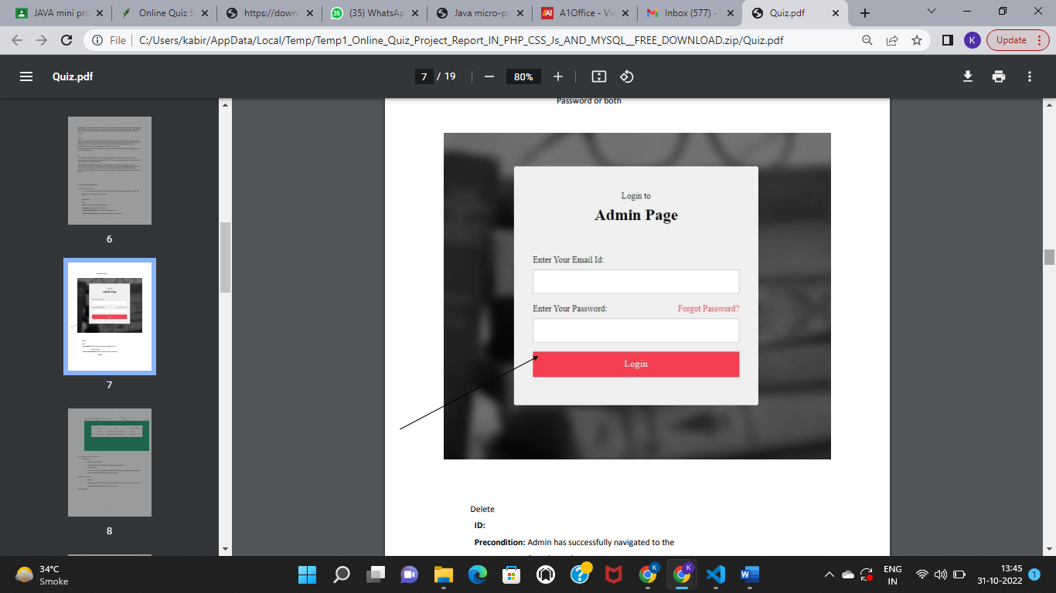

Delete

ID:

Precondition: Admin has successfully navigated to the Search result

Success end Condition: Admin has successfully made the Changes

**Software Product Features**

Online Quiz

¬ Sequencing information -Login information should be filled before the user allowed.

¬ Error Handling -If user doesn’t filled up validate information then the system display error message for user and request to enter the validate information.

Performance required

¬ Security -System should be Protected from unauthorized access Where the validate Username and Password are required so no other can access.

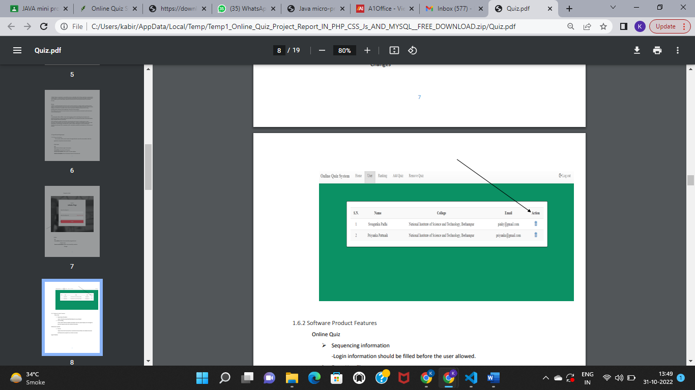

**Snapshots of working project:**

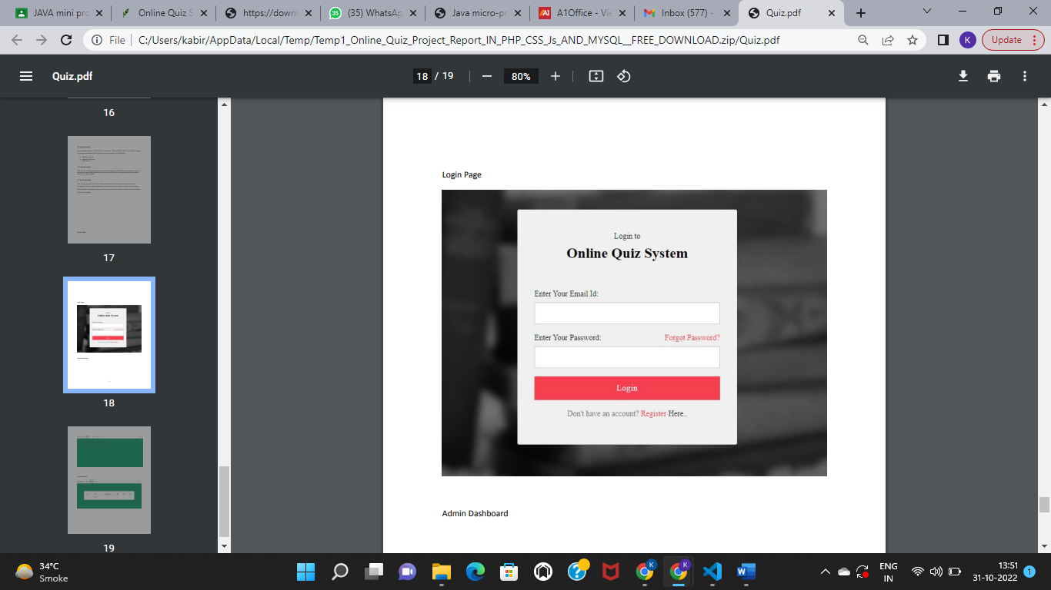

**Admin page:**

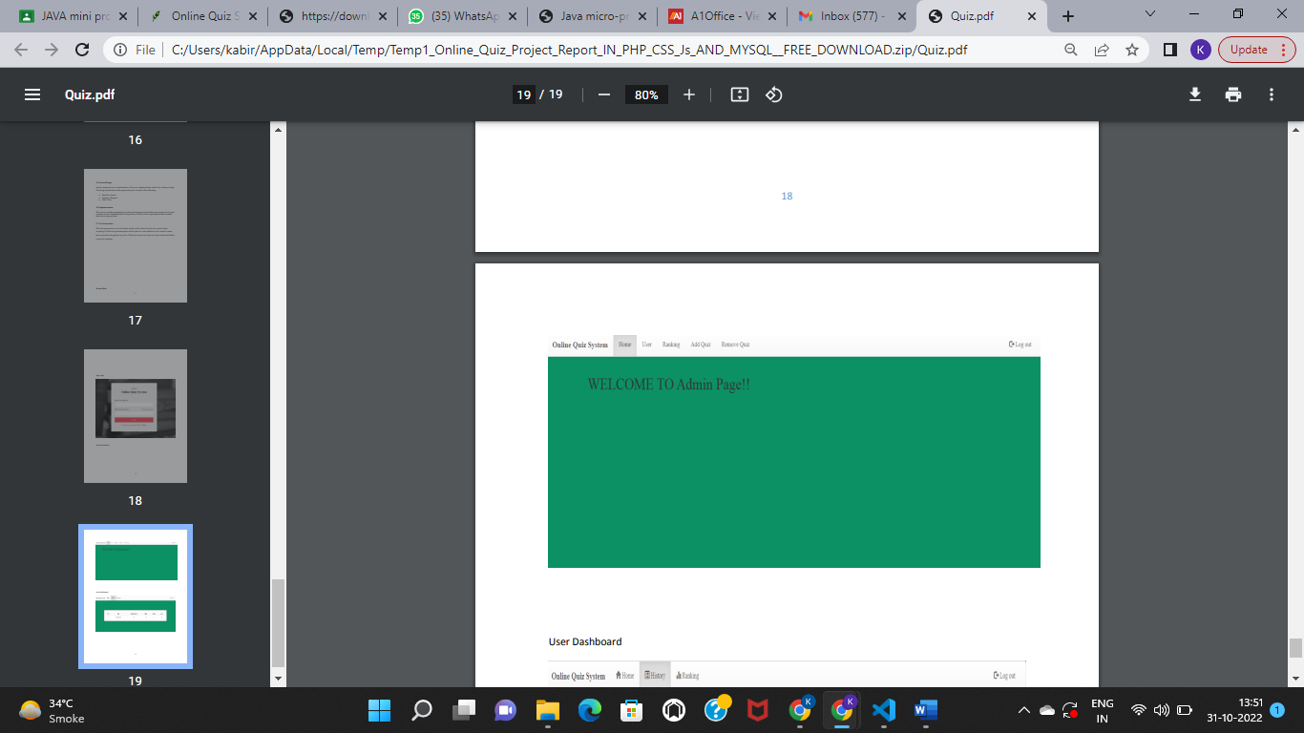

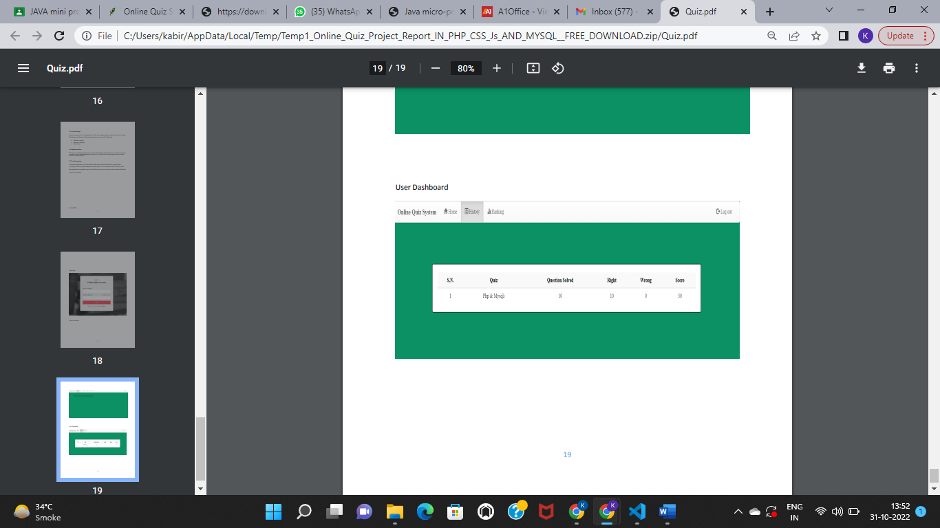

**Chapter 4**

**Results and Discussions**

FUTURE SCOPE :

It’s always interesting to see how people use question slides, sometimes among the content slides as knowledge check questions, sometimes as pretest and sometimes to validate the learning through a post-test. In any of these scenarios, especially while using the question slides as knowledge check, we hit upon something known as Quiz Scope. What’s that by the way? We all know about it but may not be familiar with the exact terminology “Quiz Scope”.

**Chapter 5**

**Conclusions**

The package was designed in such a way that future modifications can be done easily. The following conclusions can be deduced from the development of the project.

* Automation of the entire system improves the efficiency
* It provides a friendly graphical user interface which proves to be better when compared to the existing system.
* It gives appropriate access to the authorized users depending on their permissions.
* It effectively overcomes the delay in communications.
* Updating of information becomes so easier.
* System security, data security and reliability are the striking features

**Chapter 6**

**References**

<https://www.researchgate.net/publication/339577855_Online_Quiz_Application_for_Informatics_and_Information_System_Students_Task_Portal_Development> (published in 2020)

<https://www.researchgate.net/publication/352133093_The_Impact_of_Online_Quizzes_on_Student_Success> (published in 2021)

<https://doi.org/10.30534/ijatcse/2021/261042021> (published in 2021)

**CHAPTER 6**

**Acknowledgement**

I am profoundly grateful to Prof. GUIDE NAME for his expert guidance and continuous encouragement throughout to see that this project rights its target.

I would like to express deepest appreciation towards Dr. Varsha Shah, Principal RCOE, Mumbai and Prof. ____________ HOD____________ Department whose invaluable guidance supported me in this project.

At last I must express my sincere heartfelt gratitude to all the staff members of Computer Engineering Department who helped us directly or indirectly during this course of work.

Kabir Selot .

Mahira Fakih.

Mariyum Siddique.

Humza Khan.